MULLER INDUSTRIES USA

Battery Management System

User’s Guide

MIUSA- BMSLV

IMPORTANT!
------------------------------------------------------------------------------------------
MIUSA-BMSLV (Battery Management System) should only be attached to a Muller Industries USA System.

Read all installation instructions prior to installation of the Muller Industries USA, MIUSA-BMSLV

1. SAFETY INFORMATION......................................................................................................4

2. MIUSA-BMSLV Features and Modes of operation...........................................................4
Charge Control..........................................................................................................................6
Discharge Interrupt....................................................................................................................6
Temperature Monitoring............................................................................................................6
Isolation Measurement..............................................................................................................6
Using a laptop to talk to the MIUSA-BMSLV.............................................................................6
Resetting -BMSLV.....................................................................................................................6
CAN Communication.................................................................................................................7
Mechanical.................................................................................................................................8

3. INSTALLATION.....................................................................................................................8

4. LIMITED WARRANTY..........................................................................................................12

1. SAFETY INFORMATION
The MIUSA-BMSLV (Battery Management System) must be used in accordance with the manufacturer’s specifications and guidelines for recommended use. Remove all jewelry or other metallic objects from your hands and body during the installation of the battery packs and peripherals.

2.MIUSA-BMSLV FEATURES AND MODES OF OPERATION
The MIUSA-BMSLV can perform the following functions:
• OV (Over Voltage), UV (Under Voltage), OT (Over Temperature) protection
• Interact with vehicle management unit (VMU) or system controller
• Charge control
• Inter-module balance
• Data collecting

a) OV (Over Voltage), UV (Under Voltage), OT (Over Temperature) protection: In case any one of battery cells has a voltage or temperature out of the operational range, the system will issue first a warning, then an alarm. An alarm usually requests that a contactor be opened to stop the discharge or charge condition.

b) Interact with Vehicle Management Unit (VMU): MIUSA-BMSLV will communicate with VMU by CANbus, RS-485, or a combination of analog and digital signals to make the system work under the control of a VMU.

c) Charge control: The charge process is carried out under the control of MIUSA-MIUSA-BMSLVLV. The MIUSA-BMSLV communicates with the charger via CANbus, RS-485, or an analog output to achieve real-time control purpose.

d) Inter-module balance: When the MIUSA-BMSLV detects there is SOC (State Of Charge) difference between battery packs, it will engage the inter-module balance circuit of the pack with higher SOC.

e) Data collecting: the MIUSA-BMSLV will poll all of the modules for the battery information. The information is sent from the MIUSA-BMSLV via a Controller Area Network bus line (CANbus).

The MIUSA-BMSLV functions in the following modes:
• Drive Mode: The MIUSA-BMSLV will enter the drive mode if the charger is not powered on before powering on the MIUSA-BMSLV. In drive mode, the MIUSA-BMSLV will perform the function of data collecting, OV(Over Voltage), UV(Under Voltage), OT(Over Temperature) protection, and interact with VMU. All the protections are implemented by communicating with the VMU to provide a soft shut down first or by opening the main contactor so that no more current will flow out of the battery.

• Charge Mode: If the charger is powered on before powering the MIUSA-BMSLV, will detect the message from the charger when initializing and then enter charger mode. In charge mode, MIUSA-BMSLV will perform all the 5 functions listed above.

Muller Industries USA
Feature | Comments
RS-485 Communication | RS-485 Communications is used to communicate with the battery modules.
CAN interface | CAN interface will be used to communicate with the host or the charger
Charge Disconnect | When the battery modules are fully charged, they will communicate with the MIUSA-BMSLV and the MIUSA-BMSLV has the ability to turn off the charger or open the charger main contactor, interrupting current flow.
Analog/Digital Communications | In case the host controller doesn’t have a CAN interface, the MIUSA-BMSLV communicates with the host via analog/digital signals. These signals include:  Outputs –SOC (A), disable regen(D), early warning(D), MIUSA-BMS LV fault(D)  Inputs-12V ignition (D), vehicle fault (D),
Discharge Interrupt | When the batteries are discharged to the under-voltage protection point, MIUSA-BMSLV will attempt to alert the host to inhibit discharge. If discharge continues beyond this warning, the MIUSA-BMSLV will request that the main contactor open or can open it itself.
Insulation measurement | The MIUSA-BMSLV will check to make sure the battery pack is sufficiently isolated from the chassis before and after the main contactor is closed.
Pre-charge circuit | To limit the inrush current into the systems capacitors, a pre-charge resistor is connected to B+ before the main contactor is closed. This also prevents arcing and pitting across the contact tips. The MIUSA-BMSLV will close an auxiliary contactor to place a resistor in line with B+. After 2 seconds, the main line contactor will close.
Inter-module Balancing | Compensates slight capacity imbalance  between different batteries when charging  .
Intra-module Balancing | Compensates slight capacity imbalance between different cell banks within one module while charging.
Size | 188 mm x 160 mm x 38mm  7.4 in x 6.3 in x 1.5 in
Weight | Approximately 550g or 1.2 lbs

Charge Control
Charge control is usually implemented by a CAN message from MIUSA-BMSLV or VMU. During the bulk stage of charge, the MIUSA-BMSLV will ask for constant charge current output (usually at a rate below 1C). In the second stage, when any one of the battery modules is nearly full, the output of the charger will be decreased to allow balancing of battery modules. The charger output will be set to zero when charge process is terminated. In case there is a voltage difference between battery modules, the MIUSA-BMSLV will engage the inter-module balance circuit of the module that shows a greater SOC. If any cell reaches 3.9V while charging, the MIUSA-BMSLV will issue an Over Voltage Warning signal. If the cell continues to reach 4.0V, the MIUSA-BMSLV will issue an Over Voltage Alarm and open the charger contactor, halting charging.

Discharge Interrupt
When the battery modules are discharged to the under-voltage protection point, meaning at least one of the battery cells is discharged to 2.8V, the microprocessor in the module will communicate with the MIUSA-BMSLV, and the MIUSA-BMSLV will send a Critically Discharged Warning signal to VMU. In the event the voltage continues to fall and is below 2.3V, the MIUSA-BMSLV will send the Critically Discharged Alarm signal and request the opening the main contactor to VMU, which will lead to open the main contactor, or MIUSA-BMSLV will open main contactor directly. The main contactor will remain open until the signal is cleared. This is done by charging the batteries with greater than 1A for at least 1 minute.

Temperature Monitoring
When the cell surface temperature in each battery modules above 60ºC, the MIUSA-BMSLV will generate a “warning” battery pack signal. When the temperature is above 65 ºC, the MIUSA-BMSLV will generate an “alarm” battery pack signal.
There is an additional temperature sensor on the circuit board of the battery module monitoring the temperature of the circuit board. When the board temperature is above 80ºC, the MIUSA-BMSLV will generate a “warning” signal. When the temperature is above 85ºC, the MIUSA-BMSLV will generate an “alarm” signal. The system should either reduce or stop current to allow the system to cool. If the MIUSA-BMSLV controls the charge and discharge contactors, it will open both to allow the temperature to cool.

Isolation Measurement
The MIUSA-BMSLV has the option of checking for sufficient isolation between the battery pack and chassis ground. If this option is selected, the MIUSA-BMSLV will perform the test before the main contactor is closed and also periodically during operation of the pack. If the isolation measurements fall below and acceptable value, the MIUSA-BMSLV will not allow the contactor to close, restricting the operation of the pack.

Using a laptop to talk to the MIUSA-BMSLV
Software and hardware is available from Muller Industries USA allow the MIUSA-BMSLV to send it’s information to a laptop via a USB-CAN adapter. All of the data listed in CAN Communications can be seen.

Resetting the MIUSA-BMSLV
The MIUSA-BMSLV can be cleared of errors by either a command via a laptop computer running the cycle monitoring software or by cycling the 12V key ignition input off and on.

CAN Communication
The MIUSA-BMSLV communicates with the system via CAN bus 2.0B. Also, the MIUSA-BMSLV collects a variety of data from each battery. The MIUSA-BMSLV sends the following information over CAN interface.
• State of Charge (SOC)
• MIUSA-BMSLV mode (standby, charge, or discharge)
• Charge State (main, equalize, or float)
• Charge Balancing (occurring or no activity)
• Battery Faults
• Lost Communication with Module
• Over Temperature Warning / Alarm
• Low Capacity / Early Warning
• Critically Discharged Warning /Alarm
• Over voltage alarm
• MAX discharge over 120A warning and then alarm
• MAX discharge over 150A warning and then alarm
• MAX discharge over 200A warning and then alarm
• MAX discharge over 250A warning and then alarm
• MAX discharge over 300A warning and then alarm
• Temp sensor failure
• Volt sensor failure
• Current sensor failure
• SOC mismatch between modules
• Over Voltage Shut Down
• Critically discharged shut down
• Pre-charge contactor failure to close
• Battery Voltage
• Battery Current
• Open contactor request
• Main contactor state
• Insulation measurement state
• Charge contactor state
• End of Charge
• Battery Max temperature
• Battery Min temperature
• Cell Min and Max voltage
• Temperature of PCBA in each module
Mechanical
The MIUSA-BMSLV is made from durable ABS Plastic. The connectors for CAN, RS-485, 12V rail etc. in the MIUSA-BMSLV meet the requirement of IP56.

3. INSTALLATION
Ensure that the batteries are installed properly. Check the stack voltage to make sure it is within the operational range (10V-150V DC for LV model or 100V~450V DC for HV model). Make sure all the communication cables have been connected between battery modules.
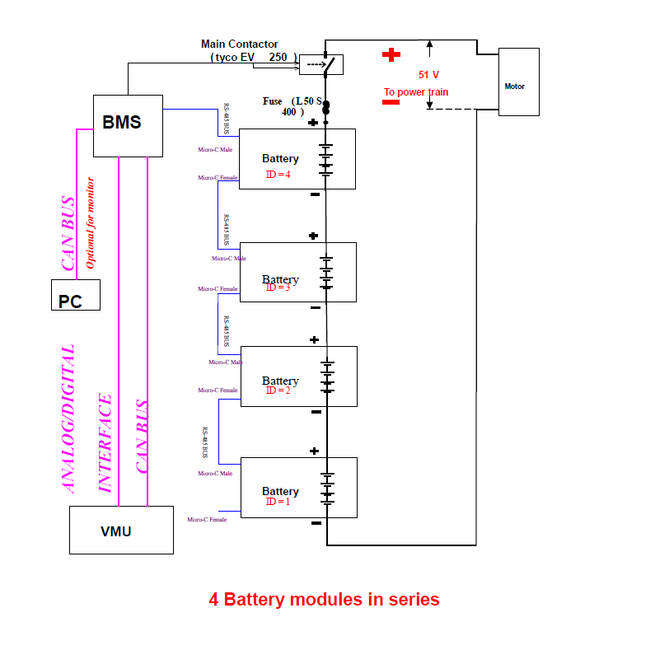
-

1
=
ID
RS-485 BUS
Micro-C Female
Micro-C Female
Micro-C Female
Micro-C Male
Micro-C Male
Micro-C Male
Micro-C Female
Micro-C Male
Battery
RS Battery
Battery
Optional for monitor
CAN BUS
ANALOG/DIGITAL
INTERFACE
VMU
Motor
)
400
S
50
L
(
Fuse
CAN BUS
PC
Battery
V
51
To power train
)
2
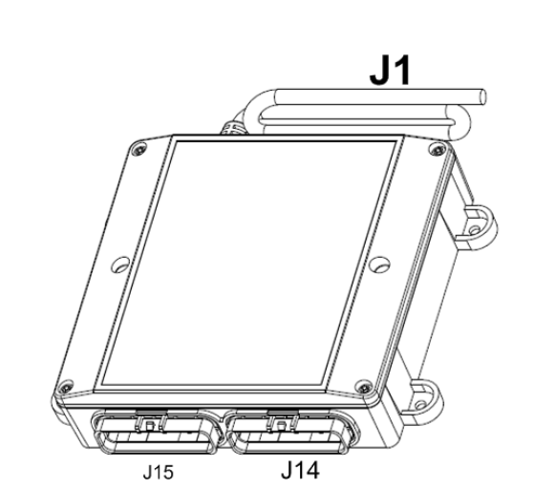

For best results, mount the MIUSA-BMSLV in an area that is easy to access, yet protected from the elements. The unit can be mounted in any orientation.
Both J14 and J15 are 26pin connectors

Connect J14 pin18, pin4, pin17, pin3, pin16of MIUSA-BMSLV to the communication connector of a battery.

The connector J14, for pin24to pin 19, pin10 to pin5, used to connect the analog and digital signals between the MIUSA-BMSLV and the device.

If the vehicle management unit (VMU), or system controller, communicates by CANbus, connect J14 pin13, pin26, pin12, pin25, pin511(CAN Interface) of the MIUSA-BMSLV to the VMU interface. It can also be connected to an USB-CAN adapter (available from your Muller Industries USA staff) to see or log the battery information on a laptop computer.

J14 CAN interface is used as the electric interface between MIUSA-BMSLV and the management unit for CAN communication.

J14 Connector DetailPin | Signal Name | Description | Maximum Rating(V)
13 | CANH | HIGH-level CAN bus line | 40

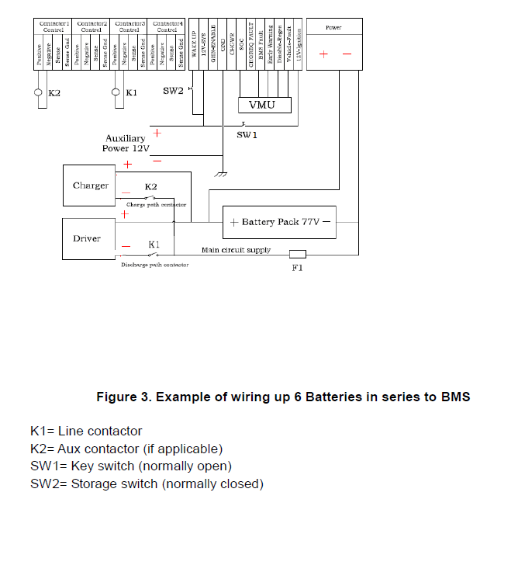
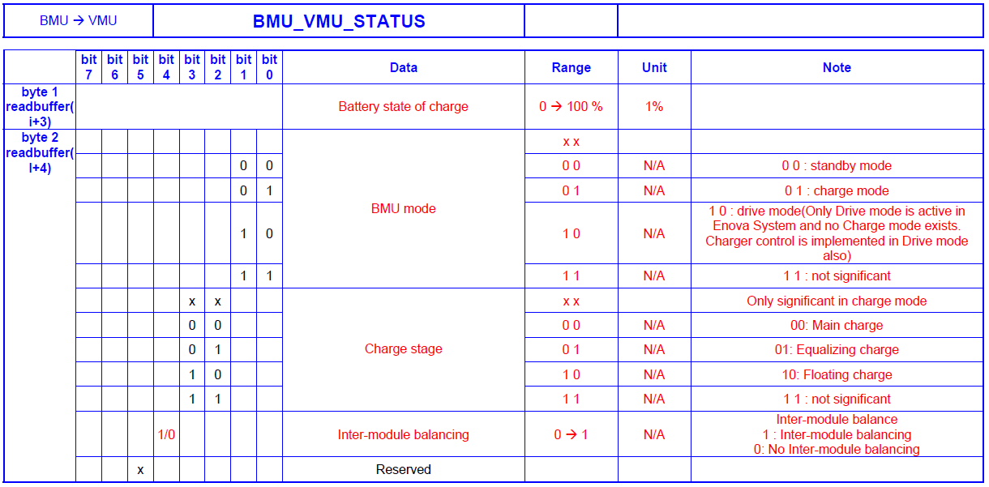

4. LIMITED WARRANTY
Muller Industries USA
MIUSA-BMSLV Limited Warranty

Muller Industries USA warrants the MIUSA-BMSLV and its components (“Product”) as free from defects in materials or workmanship under normal use for a period (“Warranty Period”) of two (2) year from the date of original retail purchase. This warranty applies to the original purchaser (the “Customer”) only and is non-transferable.
During the Warranty Period, should the Product, in Muller Industries USA opinion, malfunction, Muller Industries USA sole liability shall be, at Muller Industries USA sole discretion and at no charge to the customer, to either repair or replace the malfunctioning products if returned within the Warranty Period, freight prepaid, to the place of purchase. Each returned Product must include a written statement detailing the nature of the claimed defect, as well as the Customer's name, address, phone number and a copy of the original sales receipt showing the date of purchase.

Warranty is void if Muller Industries USA determines the Product has been:
1. Serviced by anyone other than Muller Industries USA;

2. Modified by improper installation of third-party products;

3. Damaged from accident, misuse, misapplication or abuse;

4. Damaged by improper transportation or packing when returned by the Customer to Muller Industries USA;

5. Damage by unusual physical stress or interference, failure or fluctuation of electrical Power, lightning, static electricity ,fire, or other acts of God; or

6. Operated outside of the parameters of the Manual.
THIS WARRANTY IS MADE IN LIEU OF ALL OTHER WARRANTIES, WHETHER EXPRESSED OR IMPLIED, INCLUDING BUT NOT LIMITED TO, ANY IMPLIED WARRANTY OF MERCHANTABILITY OR FITNESS FOR A SPECIFIC PURPOSE. THE REMEDY SET FORTH HEREIN SHALL BE SOLE, EXCLUSIVE REMEDY WITH RESPECT TO THE PRODUCT.

No person is authorized to make any other warranty or representation concerning the performance of the Product. Some jurisdictions do not allow exclusion of implied warranties, so the above exclusions may not apply to you. Any limited warranties that cannot be disclaimed are hereby limited to a term of one (1) year from the date of original retail purchase or, in the event relevant state law requires an implied warranty term exceeding one (1) year, for the briefest term allowable under relevant state law. Some states do not allow limitation on how long an implied warranty lasts, so the above limitation may not apply to you.
Under no circumstances will Muller Industries USA be liable for any indirect, special , incidental, or consequential damages, including any loss of revenue, loss of profit, or loss of data whether based on warranty, contract, tort, or any other legal theory, even if Muller Industries USA has been advised of the possibility of such damages. Muller Industries USA shall not be liable for any claims made by any third party or made by the Customer directly or indirectly on behalf of any third party. Some jurisdictions do not allow the exclusion or limitation of incidental or consequential damages, so the above limitation or seclusion may not apply to you.
Muller Industries USA reserves the right to change Product specifications or to discontinue the Product or other Muller Industries USA products without prior notice.

